Name______________________________ Classification
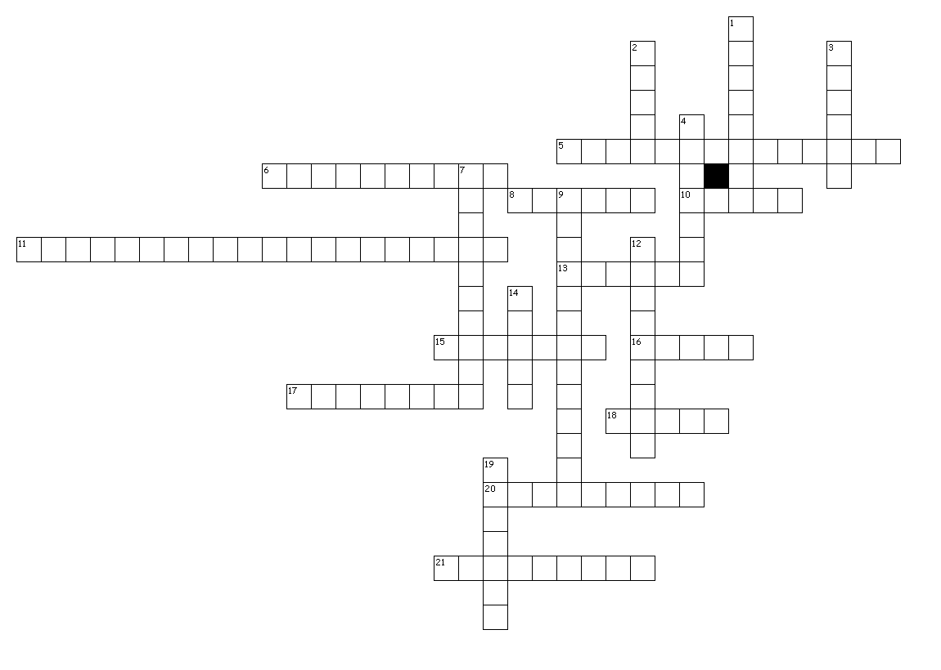
Across
5. The grouping of objects or organisms
6. Method of classifying organisms according to the order that they diverged from a common ancestor
8. A taxon of similar genera
10. A taxon of similar species
11. The system which gives each species a scientific name
13. A taxon of similar classes of animals
15. Biological species concept says organisms of the same species must be able to produce ___ offspring
16. A taxon of similar families
17. Created a system for classifying and naming organisms
18. A named group of organisms
20. The evolutionary history of an organism
21. The first person to classify organisms

Down
1. A group of similar classes of plants
2. A taxon of similar orders
3. The largest, broadest taxon
4. A group of related phyla
7. Inherited features that vary among species
9. Structural characters
12. Diagram that represents the proposed phylogeny of a species
14. All scientific names are written in __.
19. The most specific taxon
Created by Puzzlemaker at DiscoveryEducation.com

