Human Biology System: Male Reproductive
Organs | Description | Function
Sperm
Testes
Scrotum
Vas Deferens
Epididymis
Seminal Vesicle
Prostate Gland
Bulbourethral Gland (Cowper’s Gland)
Penis

*Label each of the structures in the above table on the Male Reproductive System Diagram.
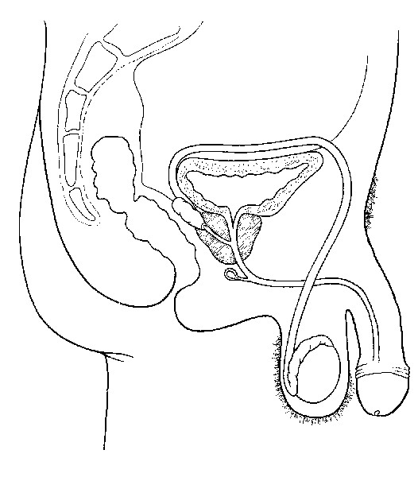
Human Biology System: Female Reproductive
Organs | Description | Function
Ovum or Egg
Ovary
Fallopian Tube or Oviduct
Uterus
Cervix
Vagina

*Label each of the structures in the above table on the Female Reproductive System Diagram.
