Biology Lab Investigation: Macro Evolution

How Are Hominids Related?

**Introduction:** Modern understanding of human origins is derived largely from the findings of [paleontology](http://www.infoplease.com/ce6/sci/A0837343.html), [anthropology](http://www.infoplease.com/ce6/society/A0804204.html), and [genetics](http://www.infoplease.com/ce6/sci/A0820469.html), and involves the process of natural selection. Thousands of fossils of human ancestors and extinct relatives have been unearthed. Each fossil, whether it is a complete skeleton, or a single tooth, contributes significantly to our understanding of human evolution. From environmental to social/behavioral change, there are many factors that may have influenced our early ancestors.

Humans and their immediate ancestors, known as hominids, are notable among hominoids for their bipedal locomotion, slow rate of maturation, large brain size, and, at least among the more recent hominids, the development of a relatively sophisticated capacity for language, tool use, and social activity.

The word "hominid" refers to members of the family of humans, Hominidae. Hominids are included in the super family of all apes, the Hominoidea, the members of which are called hominoids.

Biologists represent evolutionary relationships among organisms using phylogenetic trees. A phylogenetic tree or evolutionary tree is a branching diagram or "[tree](http://en.wikipedia.org/wiki/Tree_(graph_theory))" showing the inferred [evolutionary](http://en.wikipedia.org/wiki/Evolution) relationships among various biological entities based upon similarities and differences in their physical and/or genetic characteristics.

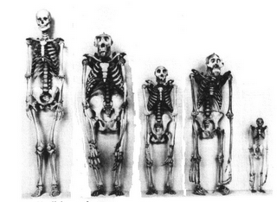**Your Task:** Using skull measurements and observations of hominidskulls you will attempt to develop a phylogenetic tree for hominids.

The guiding question for this investigation is: **How are hominids related?**

**Materials:**

* Pictures of the skulls of 2 living hominids (humans and chimpanzees) and 5 extinct species of hominids.
* Two sets of Hominid skulls (for additional measurements).
* Hominid Teeth Information Sheet
* Meter Stick
* Poster Board
* White Paper

**Safety Precautions:** There are no specific safety issues related to this lab that you need to be aware about. Be sure to follow all normal lab safety rules

**Getting Started:** Your first step will be to carefully examine the skulls and note the many similarities and differences between them. You will need to examine:

1. The braincase…
   1. Does the FOREHEAD (frontal bone) look more vertical OR flatter when the skull is held in normal anatomical position (NAP)? NAP means with the eyes oriented forward.
   2. Is a SUPRAORBITAL BROWRIDGE present? If present, is the BROWRIDGE DIVIDED in the middle, or CONTINUOUS? How big is it?
   3. What is the SIZE OF THE BRAINCASE (front to back)?[mm]
   4. Is a SAGITTAL CREST present?
   5. Is the MASTOID PROCESS relatively flat OR does it noticeably protrude (project)?
2. The face…
   1. Are the NASAL BONES raised (arched) OR flat?
   2. Measure the MAXIMUM HEIGHT of the NASAL OPENING [mm].
   3. Measure the LENGTH of the MANDIBLE [mm].
   4. Measure the slope of the face [sharp slope, gentle slope]
3. The dentition…
   1. When viewed from the side, are the INCISORS angled out OR are they vertical?
   2. Measure the COMBINED WIDTH or BREADTH of the 4 INCISORS together. [mm]
   3. Does the CANINE tooth project above the chewing surfaces of the other teeth?
   4. Is a CANINE DIASTEMA present?
   5. Measure the COMBINED LENGTH of the LEFT 2 PREMOLARS and 3 MOLARS together by measuring from the back of the last molar to the front of the first premolar to determine the length of the chewing surface of the "cheek teeth". [mm]. (NOTE: Measure the right side if the left side is missing any of these 5 teeth.

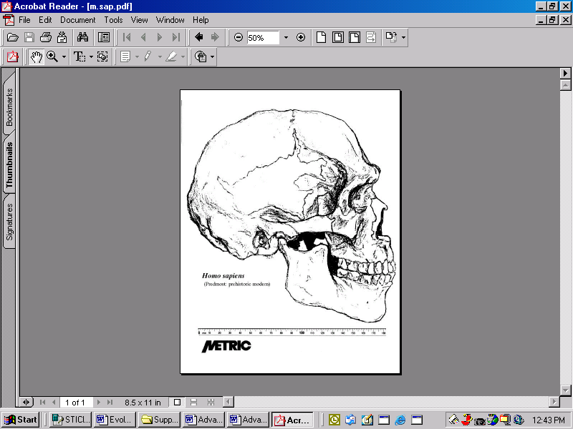

MASTOID PROCESS

SUPRAORBITAL BROWRIDGE

SIZE OF THE BRAINCASE

SAGITTAL CREST

NASAL BONE

LENGTH of the MANDIBLE

SLOPE OF FACE

Figure 1. Skull measurements

Once you have collected your data, you will need to construct a phylogenetic tree for the Hominids in the claim section of your whiteboard. Start by using a meter stick to draw 12 equally spaced lines on the board. Each line will be used to indicate an interval of 500,000 years. Then draw labeled boxes to indicate the time span that each hominid species was alive on Earth (see Figure 2). You can then draw lines between each species to show the evolutionary history of the hominids.

|  |  |  |  |  |  |  |  |  |  |  |  |  |  |
| --- | --- | --- | --- | --- | --- | --- | --- | --- | --- | --- | --- | --- | --- |
|  |  |  |  |  |  |  |  |  |  |  |  |  |  |
|  |  | Gorilla | | | | | | | | | | | |
|  |  |  |  |  |  |  |  |  |  |  |  |  |  |
|  |  |  |  |  |  |  |  |  |  | H. erectus | | |  |
|  |  |  |  |  |  |  |  |  |  |  |  |  |  |
|  |  |  |  |  |  |  |  |  |  |  |  |  | H. sapiens |
|  |  |  |  |  |  |  |  |  |  |  |  |  |  |
|  | 6 MYA | | 5 MYA | | 4 MYA | | 3 MYA | | 2 MYA | | 1 MYA | |  |

Figure 2. How to create a phylogenetic tree for hominids

**As you work through this activity, be sure to conside what data and evidence are the realtionship between them. Also, think about the different ways and/ or methods that can be used by scientists to answer questions.**

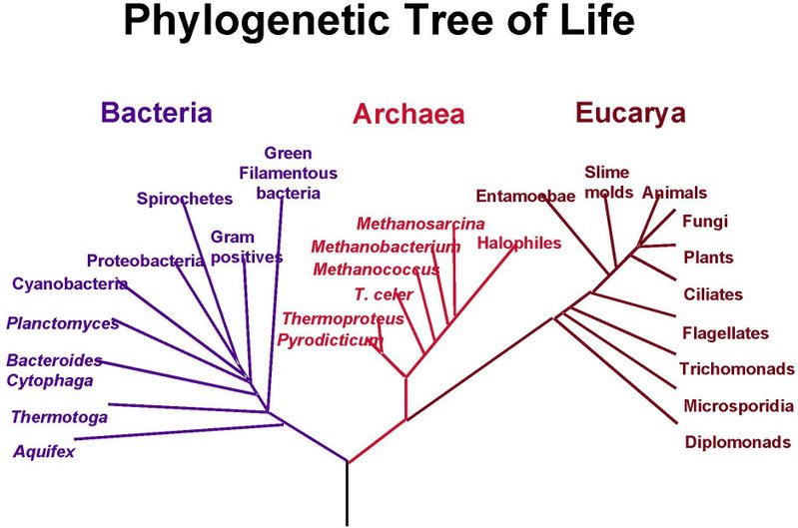

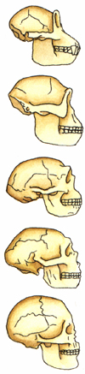

Figure 3. Hominid SkullsFigure 4 .An Example of a Phylogenetic Tree

**Table 1. Information about the Hominid Skulls**

|  |  |  |  |
| --- | --- | --- | --- |
| Name | Oldest Specimen | Youngest Specimen | Where found |
| 1. Australopithecus boisei | 2.3 MYA | 1.2 MYA | Ethiopia, Tanzania, Kenya |
| 1. Australopithecus afarensis | 3.6 MYA | 2.9 MYA | Ethiopia |
| 1. Chimpanzee | 4.9 MYA | Today | Africa |
| 1. Homo erectus | 2 MYA | 400 KYA | Africa, Asia, and Europe. |
| 1. Homo neanderthalensis | 250 KYA | 45 KYA | Europe and the Middle East |
| 1. Homo sapiens | 200 KYA | Today | Worldwide |
| 1. Cro-Magnon | 40 KYA | 10 KYA | Europe and East Africa |

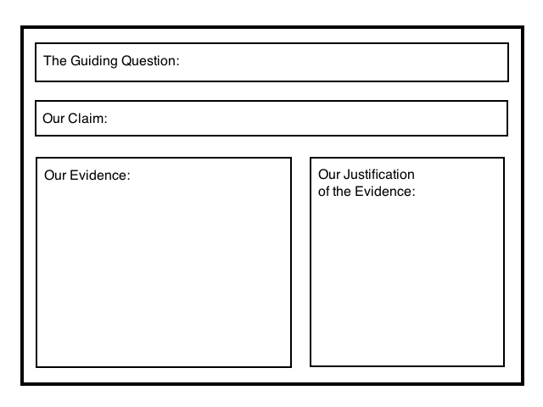**Argumentation Session:** Once your group has completed your work, prepare a whiteboard that you can use to share and justify your ideas. Your whiteboard should include all the information shown Figure 1.

To share your work with others, we will be using a **Round-Robin** format. This means that one member of your group will stay at your work station to share your groups’ ideas while the other group members will go to the other group one at a time in order to listen to and critique the arguments developed by your classmates. When the session is over, you will have a chance to meet with your group and revise your original argument. Figure 1. A whiteboard

**Report:** Once you have completed your research, you will need to prepare an ***investigation report*** that consists of three sections. Each section should provide an answer for the following questions:

1. What were you trying to do and why?
2. What did you do during your investigation and why did you conduct your investigation in this way?
3. What is your argument?

Your report should answer these questions in 2 pages or less. This report must be typed and any diagrams, figures, or tables should be embedded into the document. Be sure to write in a persuasive style; you are trying to convince others that your claim is acceptable or valid!

Hominid Teeth Information Sheet

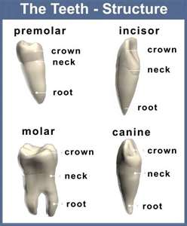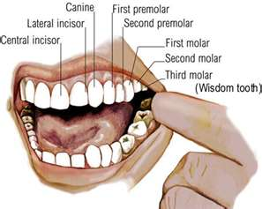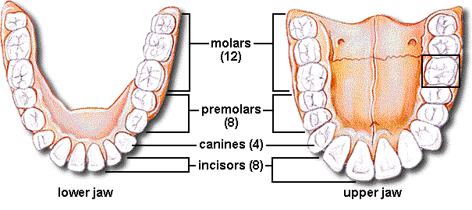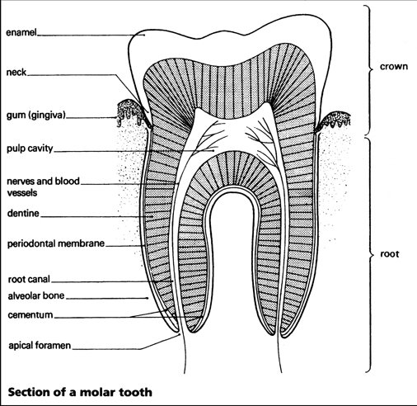

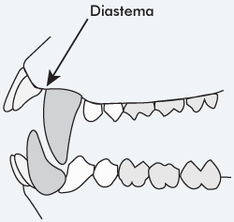

The diastema is a tooth gap found in Old World monkeys and apes. A diastema is located between the upper second incisor and the upper canine to accommodate the large lower canine so the jaw can close comfortably. The crown of the first lower premolar is slanted backwards to accommodate the large upper canine.

Name: Student Number:

Teacher: Period: Date:

**Check Out Questions**

**Biology Lab Investigation: Macro Evolution**

1. **Describe** the process of *speciation*.

Figure 1 below is a suggested evolutionary tree for the African Great Apes. The arrangement of this pathway is based on genetic information taken from the mitochondria of the various apes. Figure 2 shows a PCR analysis of genomic DNA below from human, chimpanzee, orangutans, and gorilla.

|  |  |
| --- | --- |
| Time 🡪 |  |
|  | Difference in Mitochondrial DNA |
|  |  |
| Figure 1. A hypothesized evolutionary lineages of the African Great Apes | |

|  |  |  |  |  |  |  |  |  |  |  |  |
| --- | --- | --- | --- | --- | --- | --- | --- | --- | --- | --- | --- |
| Human | **ARG** | **ARG** | **ARG** | **LYS** | **HIS** | **GLU** | **VAL** | **GLY** | **VAL** | **VAL** | **LEU** |
| Chimp | **ARG** | **ARG** | **LYS** | **LYS** | **HIS** | **GLU** | **VAL** | **GLY** | **VAL** | **VAL** | **VAL** |
| Orangutan | **ARG** | **ARG** | **LYS** | **LYS** | **GLU** | **GLU** | **GLY** | **GLY** | **VAL** | **VAL** | **VAL** |
| Gorilla | **PRO** | **ARG** | **LYS** | **LYS** | **GLU** | **GLU** | **VAL** | **VAL** | **VAL** | **VAL** | **VAL** |
| Figure 2. PCR analysis of genomic DNA from humans and African great apes. | | | | | | | | | | | |

1. **Use** what you know about the process of speciation **to explain** degree of relatedness between the various species, the common ancestors of each, and the time when the speciation took place.

**The Nature of Science and Scientific Inquiry**

**Directions:** You will read a series of statements related to two different aspects of science and scientific inquiry. Please read EACH statement carefully and then indicate the degree to which you agree or disagree with EACH statement by circling the appropriate letters to the right of each statement (SD = Strongly Disagree; D = Disagree More Than Agree; U = Uncertain or Not Sure; A = Agree More Than Disagree; SA = Strongly Agree).

**Data and Evidence**

|  |  |
| --- | --- |
| 1. In science, the term ‘data’ and the term ‘evidence’ have the same meaning. | SD D U A SA |
| 1. Evidence is information used by scientists to prove their ideas. | SD D U A SA |
| 1. Data are observations or measurements collected during an investigation. | SD D U A SA |
| 1. Evidence is data that has been analyzed and then interpreted by scientists. | SD D U A SA |

**Scientific Investigations**

|  |  |
| --- | --- |
| 1. Scientists rely on many different types of methods such as experiments, fieldwork, systematic observations, and the analysis of an existing data set. | SD D U A SA |
| 1. All scientists follow the same step-by-step method during an investigation (i.e., all scientists use the scientific method). | SD D U A SA |
| 1. Scientists reach true and accurate conclusions when they use the scientific method. | SD D U A SA |
| 1. The method used by a scientist during an investigation depends on what is being studied and the nature of the research question they are trying to answer. | SD D U A SA |